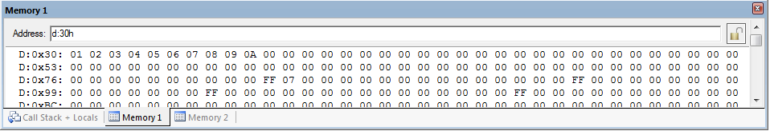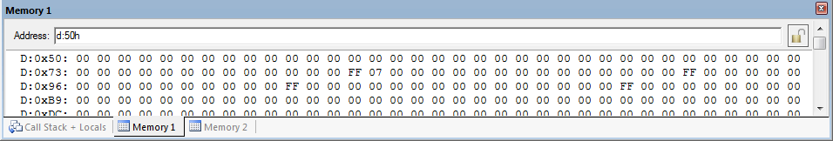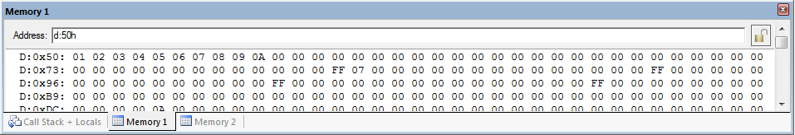

After Execution -

Before Execution -

Output 1A -